
Project Proposal
AI-Integrated Study Pilot
Department of Computer Sciences
Namal University
Mianwali, Pakistan
Submission Date: 9th October, 2026
Course Title:
CSC-225 - Software Engineering
Submitted To:
Ms.Asiya Batool
Lecturer, Department of Computer Science
Submitted By:
Reference no. | Name | Registration no. | Email ID
1 | Dua | NUM-BSCS-2025-14 | bscs25f14@namal.edu.pk
2 | Huma Aslam | NUM-BSCS-2025-20 | bscs25f20@namal.edu.pk
3 | Amna Bibi | NUM-BSCS-2025-07 | bscs25f07@namal.edu.pk
4 | Muhammad Bilal | NUM-BSCS-2025-34 | bscs25f34@namal.edu.pk

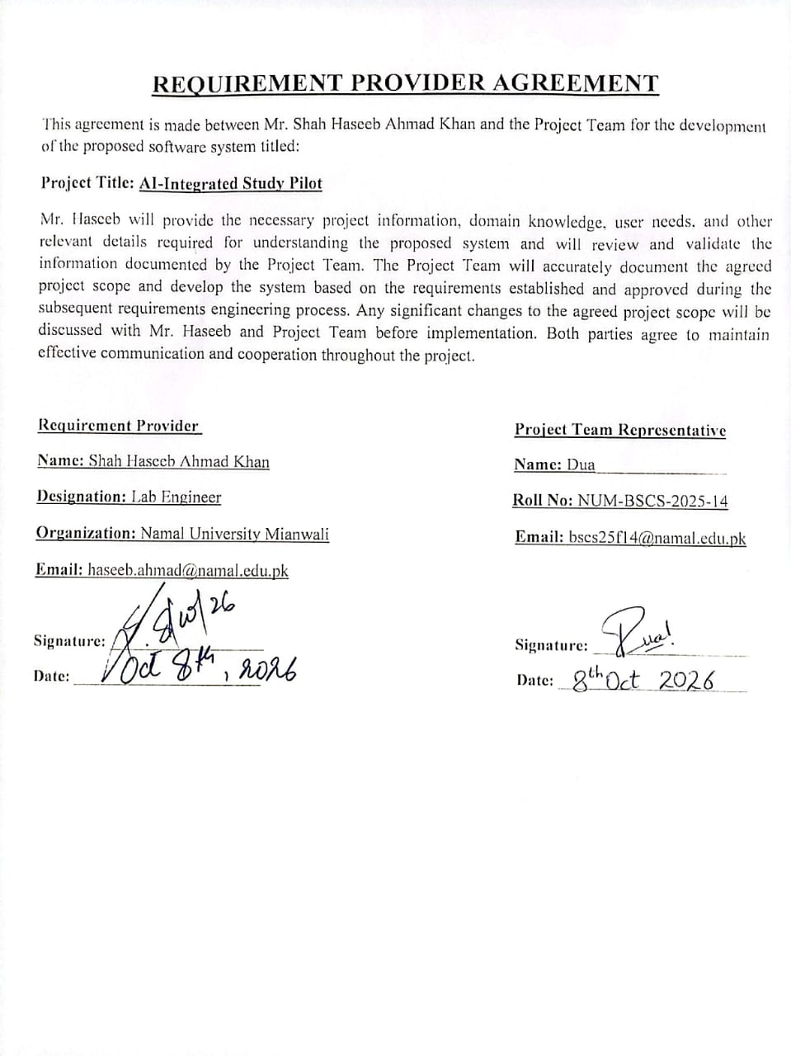

TABLE OF CONTENTS
1. INTRODUCTION: 4
2. PROBLEM STATEMENT: 4
3. PROJECT OBJECTIVES: 4
4. PROJECT SCOPE: 4
5. STAKEHOLDER IDENTIFICATION: 5
6. SOFTWARE DEVELOPMENT METHODOLOGY: 6
6.1 How does the methodology guide the phases? 6
6.2 How does the team organize the work? 7
6.3 How feedback and changes are handled? 8
6.4 Gantt Chart 8
7. TOOLS AND TECHNOLOGIES: 9
Project Repository 9
REFERENCES 9

INTRODUCTION:
University students have to manage many academic activities during a semester. These activities include assignments, quizzes, lab tasks, presentations and other important academic work. Because students have to handle many tasks at the same time, it can become difficult for them to remember every task and its submission deadline.
To solve this problem, we are proposing an AI-integrated Study Pilot. This is a prototype-based system. In this system students will add their academic tasks using text or voice. The system automatically understands the task details, dates, and deadlines. The tasks will be shown on dashboard and calendar. The system will also provide reminders when deadlines are getting closer.

PROBLEM STATEMENT:
University students have to manage multiple academic tasks at the same time, including assignments, quizzes, lab tasks, presentations and other class activities. When the number of tasks increases, it becomes difficult to remember every task and its submission deadline. Some students depend on their memory, personal notes, WhatsApp class groups or phone alarms to keep track of their work. However, these methods do not provide one proper place to manage all academic tasks. They may also require students to enter information manually or wait for a response from other students when they need to confirm a deadline.
Because of this, students may forget important tasks or miss their submission deadlines, which can create extra stress and affect their academic performance. There is a need for a simple system that helps students organize their academic tasks in one place, add tasks through voice or text, and receive reminders before their deadlines. The proposed AI-Integrated Study Pilot aims to address this problem through a prototype that uses AI, a dashboard, a calendar and reminders to make academic task management easier for students.

PROJECT OBJECTIVES:
The main objectives of the AI-Integrated Study Pilot are:
- To help students manage their assignments, quizzes and class deadlines in one place.
- To allow students to add academic tasks using voice or text input, whichever is easier for them.
- To use speech-to-text and AI to identify task details, dates and deadlines from the information provided by students.
- To display tasks and upcoming deadlines clearly through a dashboard and calendar.
- To develop a simple and user-friendly working prototype that demonstrates task management and reminders based on the requirements agreed upon with the Requirement Provider.

- PROJECT SCOPE:

The project will focus on developing a prototype of the AI-Integrated Study Pilot that helps university students manage their academic tasks and deadlines. The main features included in the project are:
- Voice and text input: Students will be able to add their academic tasks using voice or text.
- Speech-to-text and AI: The system will convert voice input into text and use AI to identify the task details, dates and deadlines.
- Dashboard: A dashboard will display the student's tasks and upcoming deadlines in one place.
- Calendar: A calendar view will show academic tasks according to their dates.
- Reminders: The system will provide reminders for important academic activities and upcoming deadlines.
- Basic task management: Students will be able to add, view, edit and delete their tasks.
- Prototype development: The interface will be designed in Figma, and a website will be developed with selected AI and voice features implemented to demonstrate the main functionality.
Since this project focuses on a working prototype, the main goal is to demonstrate how these features can help students organize their academic work. The implementation of AI and voice features will depend on the requirements agreed upon with the Requirement Provider and the feasibility of the selected technologies.
- STAKEHOLDER IDENTIFICATION:

The main stakeholders of the proposed system are students, the development team, the Requirement Provider and the instructor. Each stakeholder has a different role in the development, use and evaluation of the system.

Stakeholder | Role | Interaction with system
Students | They are the main users of the system. | They will add, view, edit and delete their academic tasks using voice or text. They will also check upcoming deadlines through the dashboard and calendar and receive reminders or alerts.
Development Team | Responsible for designing, developing and testing the prototype. | The team will implement the features, check their functionality and make changes based on feedback and agreed requirements.
Requirement Provider | Provides the project requirements and explains the problem that the system aims to solve. | The Requirement Provider will review the proposed features, provide feedback after milestones and suggest changes where required.
Instructor |  | The instructor will review the project's progress, provide academic feedback and evaluate the submitted work according to the course requirements.
  Supervises and evaluates the project.

Table 1: Stakeholder, their role and their interaction with system
- SOFTWARE DEVELOPMENT METHODOLOGY:

We will follow the Agile (Scrum) methodology
This is because:
- We can work on this project in increments or in sprints
- Its requirements may change after every feedback of the milestone
- This project will be divided into sprints and after every sprint; the working part of system will be delivered.
- After every milestone, we will collect feedback from the requirement person, and any change requests will be added to the backlog for the next sprint.

How does the methodology guide the phases?
We use Agile (Scrum), so the work is done in sprints
6.1.1 Planning:
The team defines the problem and features and creates the Product Backlog by getting all requirements and making a list of them. The 12-month schedule is also made here.
6.1.2 Analysis:
We collect the requirements from the requirement person. The requirements are written and added to the Product Backlog with priorities.
6.1.3 Design:
We will design the prototype of the system using a Figma or we can design a web page web page or website by using HTML that will show the features of it.
6.1.4 Implementation:
And then we will start implementing the tasks that are defined in each sprint .Coding will also be done on this section
6.1.5 Testing:
Testing will also be done at the end of every sprint to make sure that it is exactly matching the requirement that we define in the sprint backlog
6.1.6 Delivery:
The final system, documentation and requirement person guides are delivered after all main items meet the Definition of Done and the instructor accepts them.
- Hold a short team meeting every day to check progress or to find the solution of the problem if any exist.
- By cooperating with each other in every situation
- At the end of each sprint, review also helps us to understand what is done and what we have to change

How does the team organize the work?
- Divide the work into sprints.
- Dividing the tasks to each team member.
- Use GitHub so everyone's code stays in one place.
https://github.com/duapervaiz/AI-Integrated-Study-Pilot.git

How feedback and changes are handled?
- After each milestone, we will show the work that is done to the instructor and requirement person and get their review.
- Any new idea or change is first written in the backlog.
- The team decides its priority as we are following the agile methodology.
- Important changes are done in the next sprint.
- This way the current work is not disturbed.
  - Gantt Chart
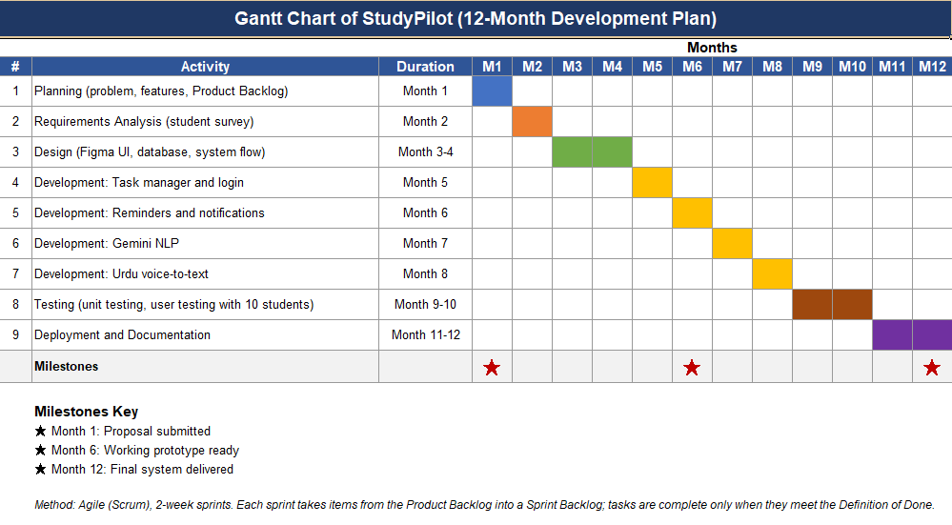
Gantt chart showing 12 month development plan

- TOOLS AND TECHNOLOGIES:

Tools and Technology | Purpose
Figma | Figma will be used to design the interface and demonstrate how the system will look and work from the user's point of view.
HTML, CSS and JavaScript | These technologies will be used to develop the website, create its layout and add interactive features.
Python and Flask | Python will be used for the backend logic, while Flask will help connect the website with the backend functionality and AI services.
SQLite | SQLite may be used to store task details and deadlines if persistent storage is required for the prototype.
AI API | An existing AI service or API will be used to identify task details and deadlines from the information provided by the student, instead of training a large AI model from scratch.
Speech-to-Text | A speech recognition service will be used to convert spoken input into text so students can add tasks by speaking. Urdu and Roman Urdu support will be explored where feasible.
Git and GitHub | These will be used to manage code versions, keep the project files organized and allow team members to collaborate on development.
Browser Notifications API | This may be used to display notifications about upcoming tasks and deadlines in the browser.
Web Speech API | This will be explored for speech recognition in the website so students can enter tasks through voice input.
Visual Studio Code (VS Code) | VS Code will be used to write, edit and manage the project's code.
Table 02: Tools and technology and their purpose
PROJECT REPOSITORY
https://github.com/duapervaiz/AI-Integrated-Study-Pilot.git

REFERENCES
[1] K. Beck et al., "Manifesto for Agile Software Development," 2001. [Online]. Available: https://agilemanifesto.org
[2] K. Schwaber and J. Sutherland, "The Scrum Guide," 2020. [Online]. Available: https://scrumguides.org/scrum-guide.html
[3] Figma, "Figma." [Online]. Available: https://www.figma.com
[4] Mozilla, "MDN Web Docs: HTML, CSS and JavaScript." [Online]. Available: https://developer.mozilla.org
[5] GitHub, Inc., "GitHub." [Online]. Available: https://github.com
[6] Python Software Foundation, "Python." [Online]. Available: https://www.python.org
[7] Pallets, "Flask Documentation." [Online]. Available: https://flask.palletsprojects.com
[8] SQLite Consortium, "SQLite." [Online]. Available: https://www.sqlite.org

AI TOOL USAGE
AI tools, including ChatGPT, were used to help brainstorm the project idea, organize the proposal sections and improve the clarity and grammar of the written content. The project details, selected features and final decisions were reviewed by the team. The team remains responsible for understanding the proposal and ensuring that the content accurately represents the project.

